

# Linux Basic Commands Assignment

***Assignment Part-3***

Playing with files

1. Create a file like **nano file1.txt**

* Edit some data and then save the file

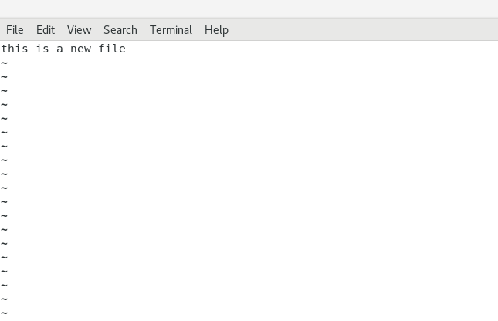

1. Now we will copy date from file1 to new file2

# o cp file1.txt file2.txt

* Then see the output of file2.txt, **cat file2.txt**
* Give screenshot

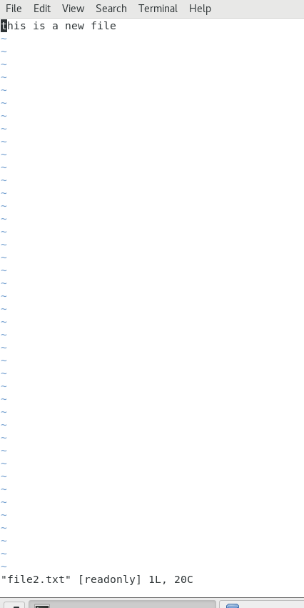

1. Now we will move the file2.txt to new folder **/home**

# mv file2.txt /home

* + Then go to **home** directory and check **ls,** file exits or not?
  + 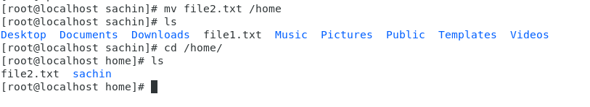Given screenshot

1. Then we create a new **file3.txt and file4.txt** in **home directory** and add content in it.

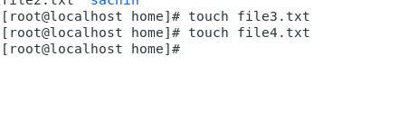

* + Now do **echo “Hello I am newline” > file3.txt** and provide the output of file3.txt

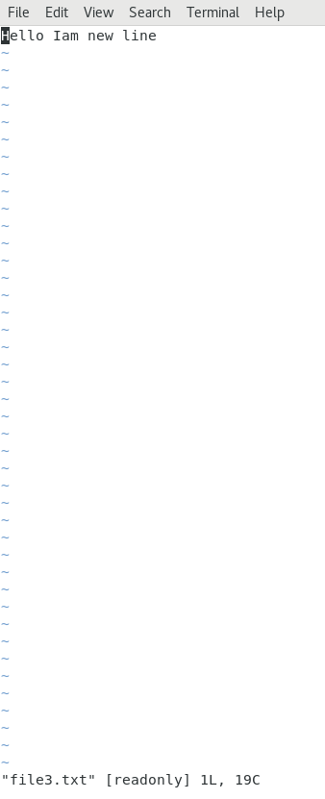

* + Now do **echo “Hello I am newline” >> file4.txt** and provide the output of file4.txt

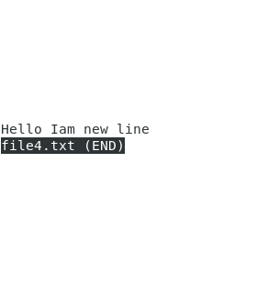

* + Tell the different between both step you follow and the reason behind it

‘>’ Appends the text to the file ‘>>’ replaces text of LHS to RHS

1. For remove a file or directory you can use the below two commands

* To delete a file – **rm <any_filename>**

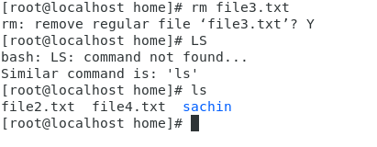

* To delete a directory - **rmdir <any_directoryname>**